just by the simple fact that we have defined a brand-new variable called my_ee using the parameter statement, is enough to tell the system we are going to generate our own selection screen. And the parameter statement is all we need to display a field on the screen.

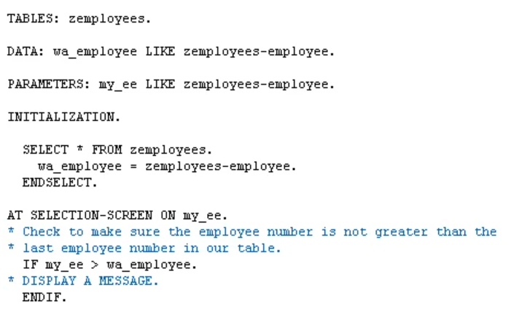

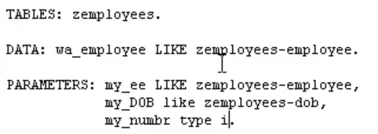

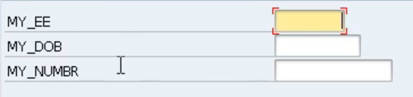

let's take a look at some of the additions we can use with the parameter statement. The first one is the default addition.





This is going to default this value into the field on the screen. Now the default is only a suggestion.

The user can override the value. You know there's nothing saying they have to use that, it's just a default value that we can populate on the screen maybe could down the amount of data we want the user to enter on the screen.

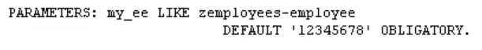



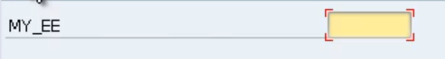

Our next addition is by making the field mandatory we can use the addition obligatory. See, you can see, this addition here when executed forces this little tick box to appear in the blank field. See if I try to run the report, we'd get this message box at the bottom, saying, Make an entry in all required fields.

So, we're telling the user you must put an entry in this field.

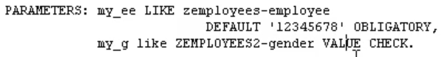

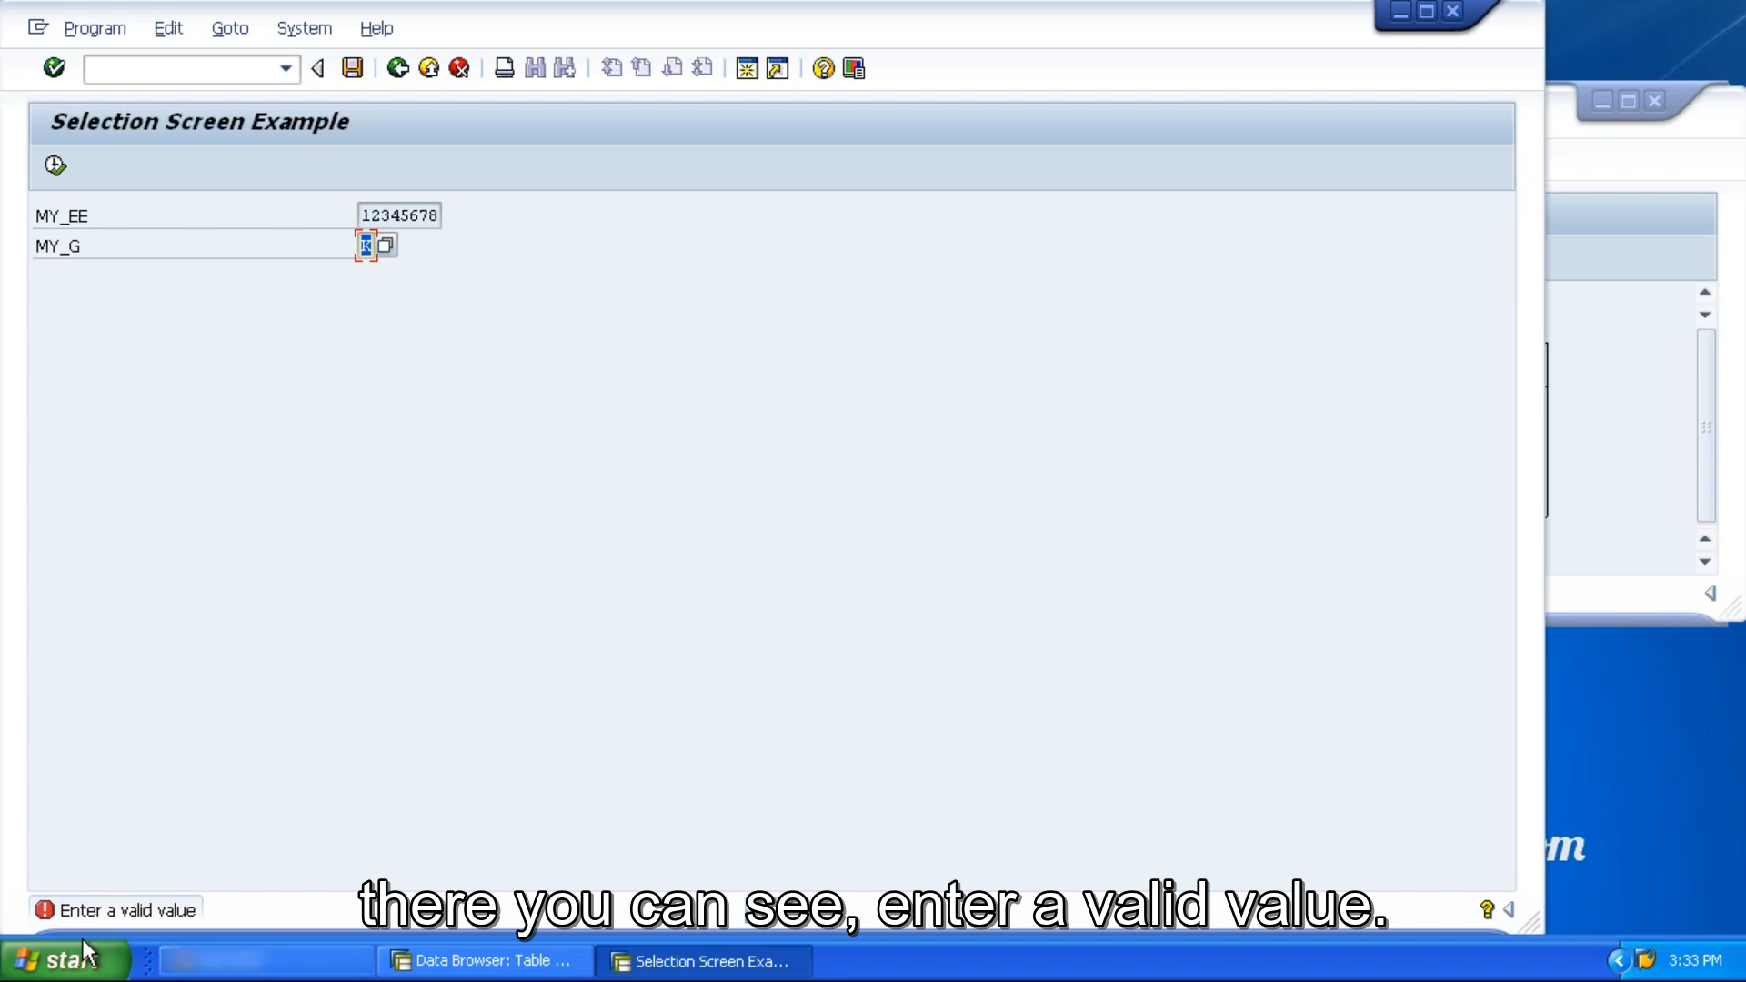



Now, another addition is the value check addition,

we're going to look at a field called gender. So, when we use this field on a selection screen, the ABAP dictionary is working away in the background, helping to ensure any fields that we use like this automatically refer to any value help text or foreign key relationships that we've already set up to help the user to select valid values.

So normally we would have to select M, F or U. Let's say I enter K. We don't get any error message or anything like that to say K is invalid. But this value check addition allows us to include value checking.

So any entry we make into this field, the program will now check that entry against a valid value list that we have defined in the ABAP dictionary. Enter K, press enter and there you can see, enter a valid value.

the last addition is going to be the lower-case addition. Remember I mentioned earlier that the parameter statement converts everything to uppercase. We can get around this by using the lower-case addition.

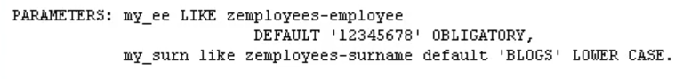

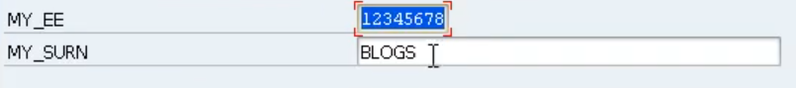

To demonstrate how this works and how it's taken effect I'm going to enter some lowercase letters. And when I press the Enter key, nothing happens.

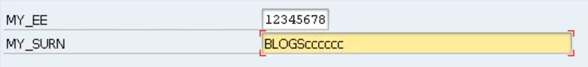

We still have the uppercase and we still have the lowercase letters in the field.

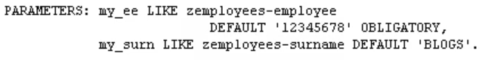

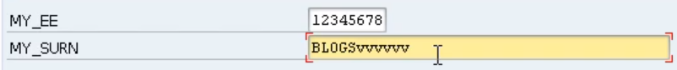

If we didn't have the value check addition there, these lowercase letters would all be converted to uppercase.

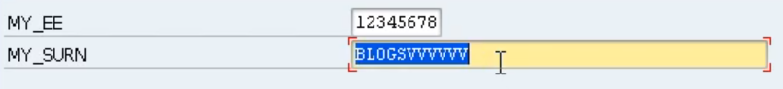when I put a load of lower-case letters in and press enter. It converts them too upper-case. Let's pop that back in.